Date : 18.06.24

SUPER MARKET PROJECT USING PYTHON

OUTPUTS:

Mobile Accessories Shop:

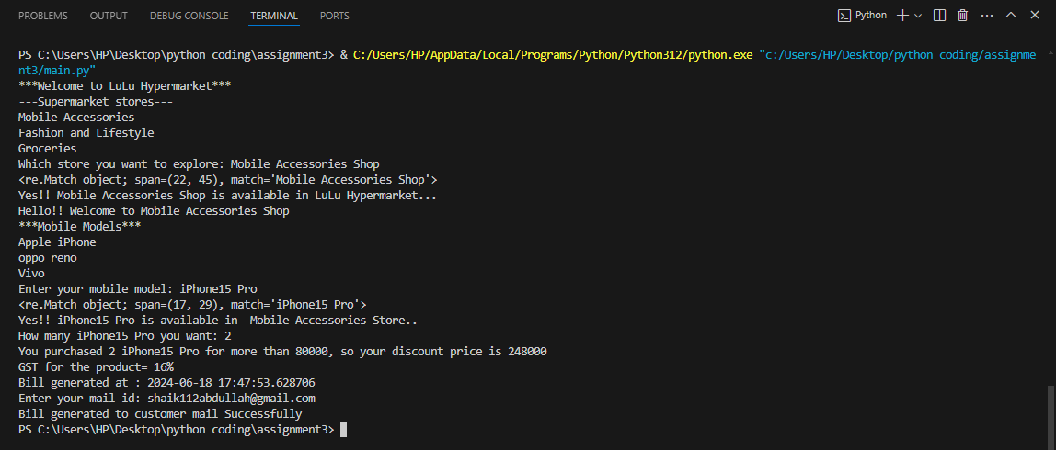

Fashion and Lifestyle Shop:

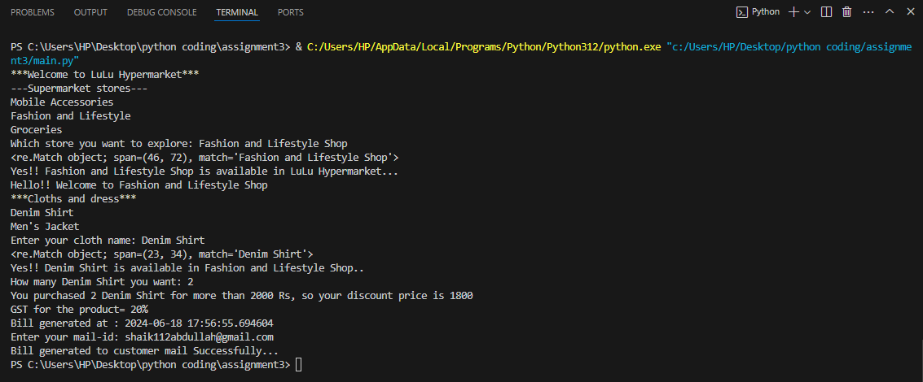

Fashion and Lifestyle Shop:

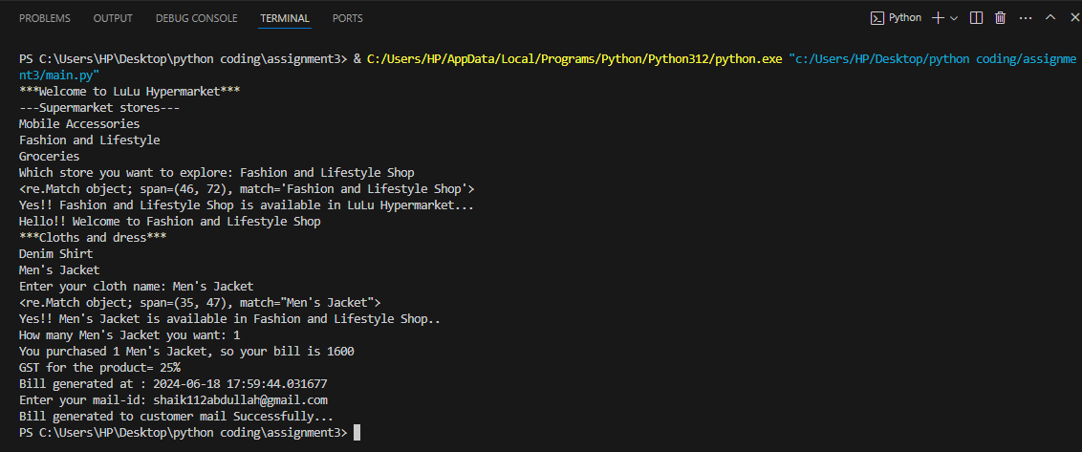

Groceries Shop:

